24th July 2019

### Yokohama Rubber’s Russian Tire Manufacturing and Sales Subsidiary Receives Nissan Best Supplier Award

YOKOHAMA announced today that its Russian tyre manufacturing and sales subsidiary, LLC Yokohama R.P.Z., has been awarded a Nissan Best Supplier Award in the chassis category from Nissan Motor’s Russian plant Nissan Manufacturing Rus LLC. The award was presented to Yokohama R.P.Z. by Nissan Manufacturing Rus General Director Igor Boitsov at an awards ceremony held in St. Petersburg on June 21, 2019.   
  
Nissan Best Supplier Awards are presented to the best suppliers in six categories. Recipients are selected on the basis of superior product quality and logistics. Yokohama R.P.Z. was selected as best supplier in the chassis category in recognition of the superior quality of its tyres and supply system, which ensures timely deliveries.   
  
Yokohama R.P.Z. was established in Russia’s Lipetsk special economic zone in December 2008 and at the end of 2011 became the first Japanese tire maker to operate a passenger car tyre plant in Russia. Today, it continues to make and sell mainly passenger car tyres, which it has been supplying as original equipment for new cars made by Nissan Manufacturing Rus since 2015.

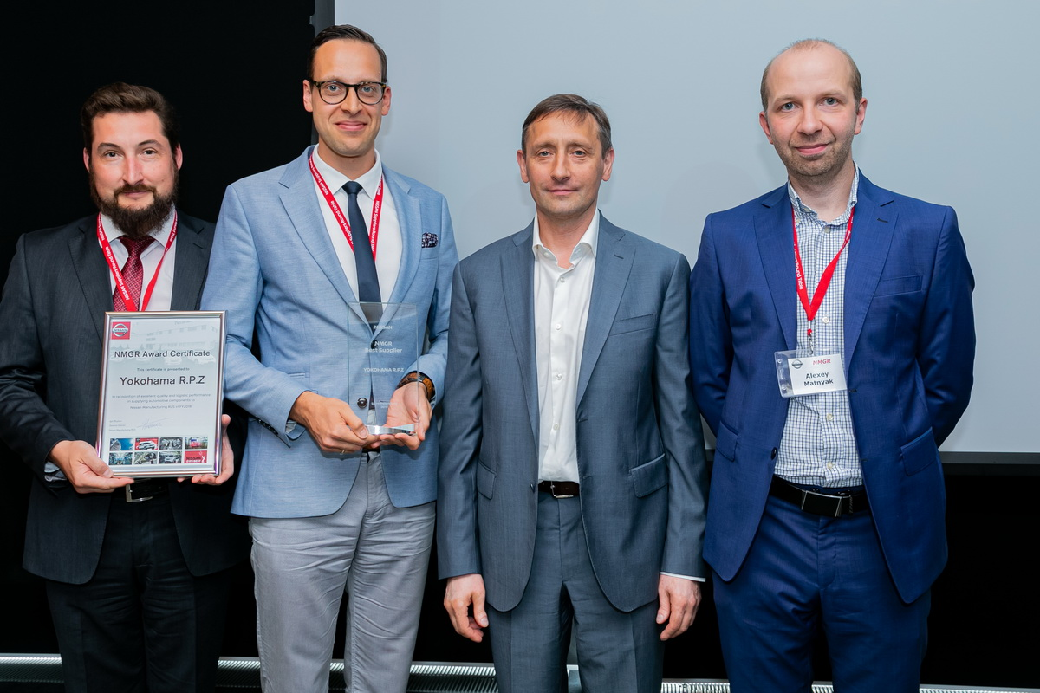

Scene from awards ceremony, managers from Yokohama R.P.Z and our Russia tire sales subsidiary Yokohama Russia L.L.C. (two on far left) accept award from Nissan Manufacturing Rus officials (two on far right)